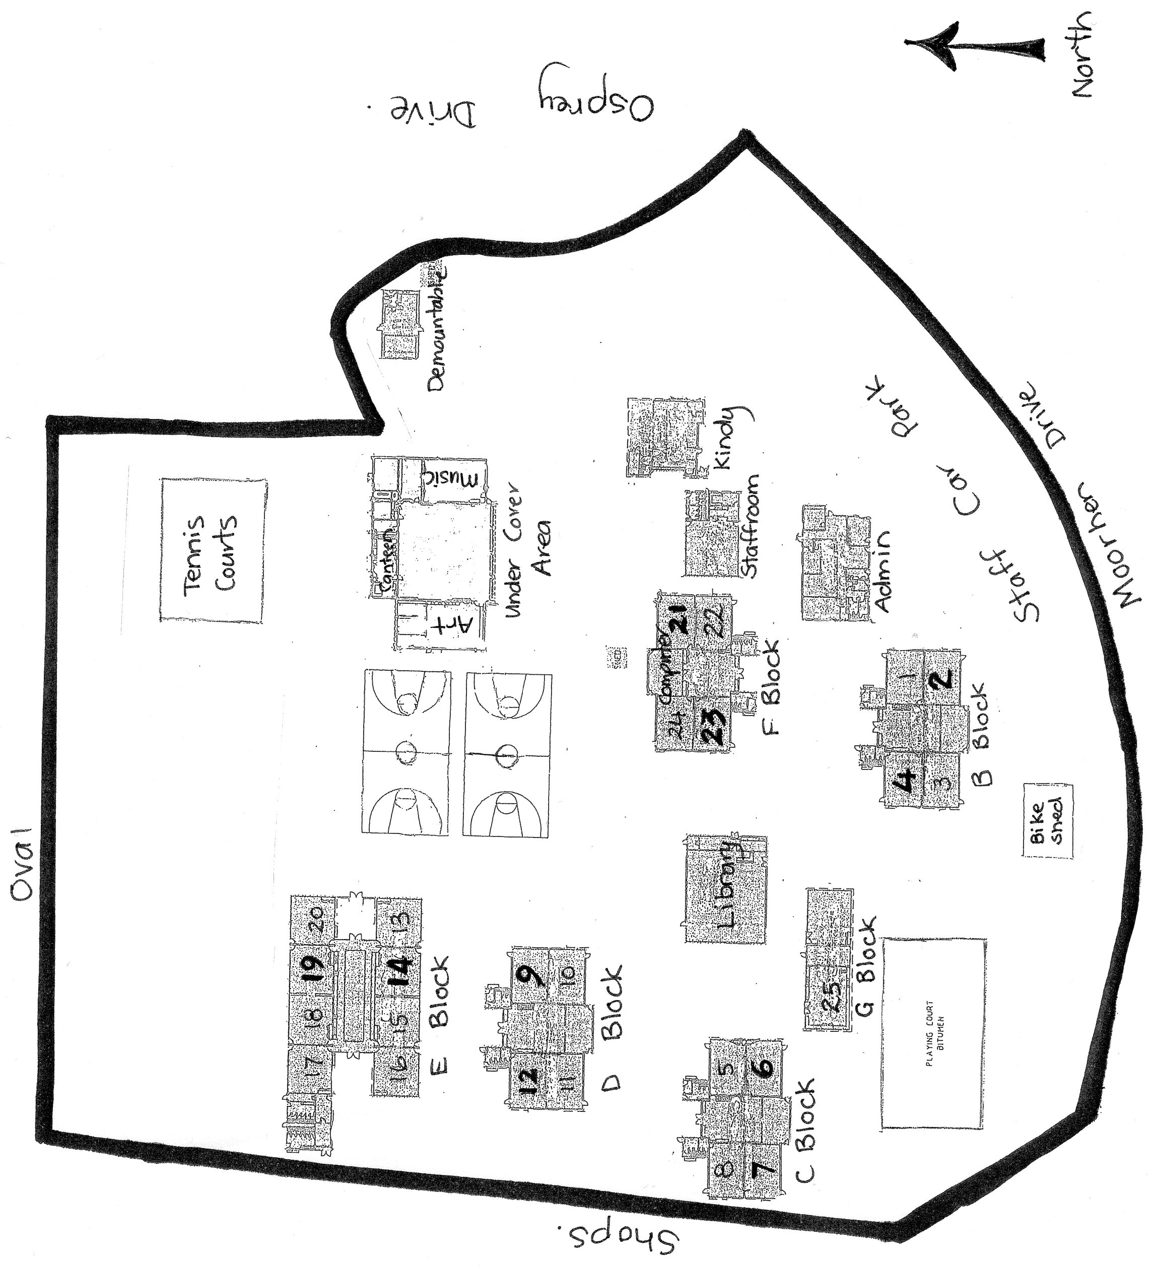

**Yangebup Primary**

**School**